Pondwatch JE – Level 1 survey form
Have you completed the data protection and consent section overleaf? | Yes |  | (please tick once complete)

Contact details
Name |  |  | Address
Tel
Email |  |  |  | Can we contact you if necessary?
Date of survey |  |  |  | (please tick as appropriate) | Yes | No

How to survey the pond
- Visit a pond of your choice once* between January and May.
(*You can make more than one visit but you will need to fill out a separate form for each visit)
- Spend 30 minutes visually searching, noting any amphibians and other pondlife that you see. (see our ID guide for help)
- Take photos, especially if you are not sure of what you have seen.
- Fill in the form below and record your results online (http://jerseybiodiversitycentre.org.je/), or send your form to: Pondwatch, Natural Environment, Growth Housing and Environment, Howard Davis Farm, Trinity, JE3 5JP.
Remember that Jersey’s native amphibians and other wildlife are protected by law, and should not be harmed, taken or possessed, nor should their breeding or resting sites be disturbed.

Pond location

(if not home address)
(address, post code or description)

Type of pond (tick one) |  |  |  | Pond construction (tick one)
Formal garden pond | Farm pond | Natural pond |  | Liner | Concrete
Wild garden pond | School pond | Reservoir |  | Preformed plastic | Clay
Fish pond | Golf course pond |  |  | Other _________________________

What did you see? Write down how many of each you counted. For tadpoles and spawn, write down a range (e.g. <10, 10‒20 etc.). *For toad spawn strings or newt eggs, just tick if you have seen some. They are difficult to count!
 | Lifestage
 | Adult | Immature | Tadpole | Spawn* | Not sure
Western toad
Palmate newt
Agile frog
Other
(species, lifestage, quantity)

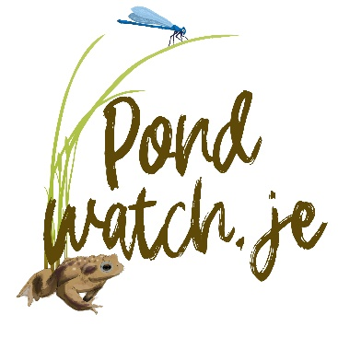
Supplementary information

When did you first see spawn in this pond this year?

Do migrating toads get run over on nearby roads? | Yes | No | (tick as appropriate)

Have you seen a grass snake in the pond? | Yes | No
Data protection and consent
Important information
Before signing this form please read the following consent information carefully. It explains how your information will be used and provides a brief description of your rights under Jersey’s Data Protection Law. For further information on how the Department of the Environment handles personal data please visit http://www.gov.je/howweuseyourinfo
Your Consent - I am aware and agree
That the personal information supplied in this form, together with any other accompanying information, is to be used for the purpose of providing metadata associated to the information collected during my volunteering activities.
That any information I collect during my volunteering activities will be shared with other interested parties (such as the Jersey Biodiversity Centre) and will be used to provide published statistical data and reports.
Volunteer consent
Signature:
Name: |  | Date:

