Paulton Toad Patrol  Risk Assessment  Spring 2021 |  |  |  |  | 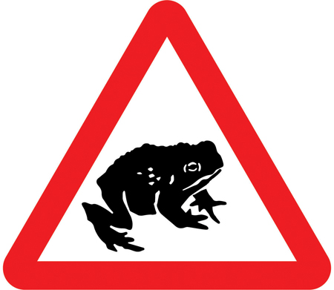
Risk assessor: Rozy Gray & Andy Ryder  Date of risk assessment: 19th Mar 2021 |  |  |  |  | Risk assessment No:  RG2021PTP
Hazard | Nature of risk | Who is at risk | Degree of risk | Prevention/Control Measures | Adjusted degree of risk
Covid 19 | Risk of transmission or infection | Volunteers | Moderate – High depending on local R rate | Volunteers to follow local tier guidance at all times and not to patrol or move between tiers if against current guidance.  Volunteers to keep at least 1 meter away from other volunteers and avoid any physical contact  Volunteers to wear facemasks when interacting with other volunteers  Volunteers to use only their own equipment & not to swap buckets  Volunteers to wash hands/sanitise after patrolling  Please don’t pick up amphibians if you have used hand sanitiser. It will likely kill them. | Low – Moderate depending on local R rate
Adverse weather conditions | Cold, wet & windy conditions could lead to accidents or adverse health issues such as hypothermia | Volunteers | Moderate | Inform volunteers of the need to wear appropriate weatherproof clothing and footwear. Volunteers to carry mobile phone in case of emergency. | Low
Risk or injury from passing motorised & non-motorised vehicles | Risk varying from minor collisions with bicycles to potentially fatal car accidents.  Bristol Road is a 30mph/ national speed limit road. There is no pavement so risk of close contact with road traffic. No streetlights and hills risks volunteers not being seen by road traffic. | Volunteers | High | Volunteers to wear high-visibility jackets, use torches at all times, to patrol in pairs and follow safety guidelines provided.  Volunteers to stand to side when vehicles approach and to be wary at all times.  Volunteers to stay alert for vehicles and bicycles at all times and to provide plenty of space when they are passing.  Volunteers never to risk personal safety to save an animal at risk from approaching vehicle. | Moderate
Crime | Threat of verbal abuse or physical attack | Volunteers | Low | Patrol activity to be publicised prior to commencing. Volunteers to patrol in pairs where possible. Volunteers to carry mobile phones. Volunteers briefed on the need to avoid confrontation and to present themselves in a courteous fashion at all times. Police given prior notification of patrol activities and to be notified of any suspicious or threatening behaviour witnessed or experienced during patrols. Volunteers asked not to carry valuables. | Low
Deep water | Minimal risk of drowning when patrolling near bodies of water. | Volunteers | Low | No need to release amphibians into water. Can be released away from road on same side as lake. If access to lake area is required at any time then volunteers to remain at least 2m from water’s edge. Volunteers to work in pairs whenever possible. Torches to be used at all times. | Very Low
Environmental/geographical factors | Risk of slipping, tripping or falling on wet paths, slopes or muddy banks. Risk of cuts, scratches and grazes from thorns, wire fences and litter. Injuries varying from trivial scratches or cuts to sprains, fractures and serious infections or tetanus. | Volunteers | Moderate | Inform volunteers of the need to wear appropriate weatherproof clothing and footwear. Volunteers to carry mobile phone in case of emergency.  Where possible volunteers to familiarise themselves with patrol area during daylight hours and to stick to paths and well-lit areas to minimise risk or accidents. | Low
Biological factors | Injury varying from trivial insect bites to waterborne diseases and serious animal bites. | Volunteers | Low | Only amphibians to be handled by volunteers. No UK Amphibian species poses any physical threat to humans and volunteers advised of the need to wash their hands after handling. Any non-amphibians encountered only to be handled by co-ordinator. Likelihood of encountering harmless grass snakes is very low after dark and adders not found at this site.  Volunteers warned of the need to avoid geese and swans if encountered.  Volunteers encouraged to cover legs and arms due to weather conditions so risk of insect bites is minimal.  Ensure that cuts and scratches are covered with waterproof plasters or microspore tape and any new injuries are correctly treated. Any injuries must be treated and where appropriate, tetanus vaccination recommended. | Low

You must read and sign this form prior to performing survey work
Signed | Print Name
Date

