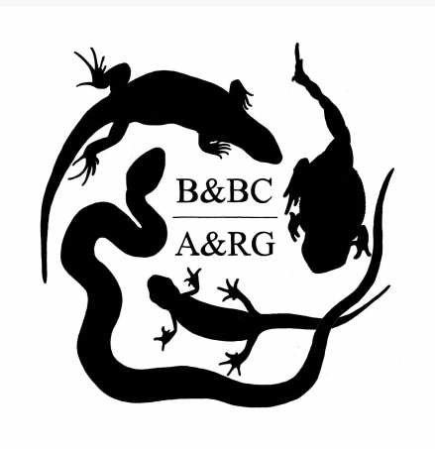
Birmingham and Black Country Amphibian and Reptile Group

Volunteer Membership form

Title: Name:

Home address: Contact address if different:

Contact details: Home Tel:

Mobile:

Email:

Emergency contact details:

Special medical requirements:

P.T.O.

Please specify which areas of volunteering you are interested in - ie practical management, monitoring, education,

How you found out about volunteering for Birmingham and Black Country Amphibian and Reptile Group?

- I understand that any further training will be given as and when required; to abide by all training and Health and Safety guidance.
- I understand that volunteering may involve working outdoors in bad weather.
- I have made staff aware of any personal issues that may stop me from completing what is asked of me.
- I agree to be checked by the Disclosure and Barring Service should the need arise.
- I agree to photos/video of me being taken during BBCARG volunteer activities and used in BBCARG publications both printed and online (inc. social media) to help with raising awareness of our work;
☐Yes
☐No

- The information that you provide on this form information is stored securely, kept strictly confidential, and not passed to third parties without prior consent. We will not include personal details on any of our printed, digital and online resources. We will only include your name on, or in relation to, images with your permission by making contact with you directly.
- European General Data Protection Regulations (from May 2018), requires us to receive proactive consent from you in order to send you information. Please tick all appropriate;
Phone ☐ Text ☐ Post ☐ Email ☐

Signed: Parent or Guardians signature (if under 18):

Date:

Please return this form to bbcarg@gmail.com

Membership to join BBCARG is £4 per annum, with renewal due May each year. Please send across to: The Amphibian and Reptile Group of Birmingham and Black Country.
Sort code: 30-98-97. Account No: 58710068.

Please put your name in the reference so we can track payments made.

